**Test Document for POWise Payment Terms**

Created new Report tdisg0401m200 PO Wise Payment Term, we test for P20100003 for only latest revision.

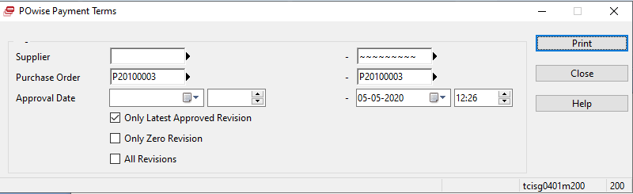

Results are:

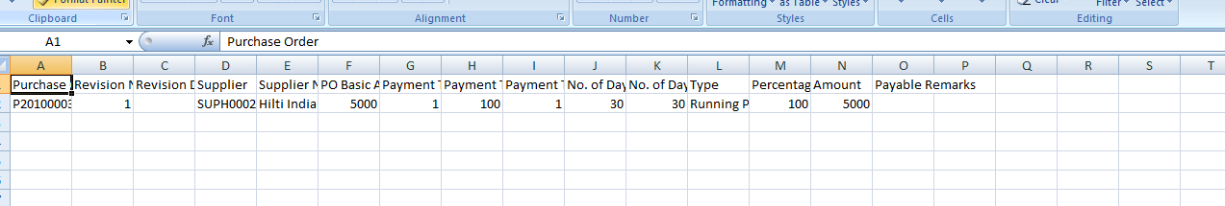

After we tested for Only 0 Revision:

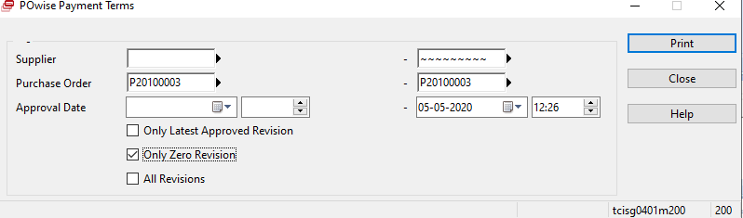

Results are:

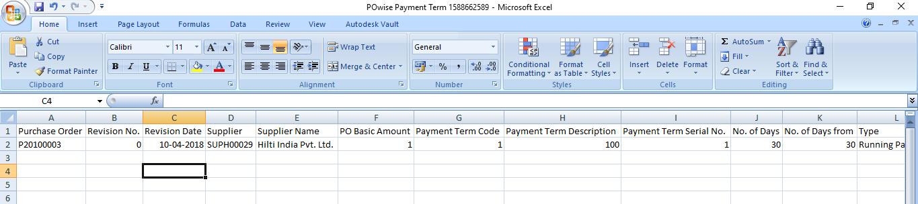

After tested for All Revision:

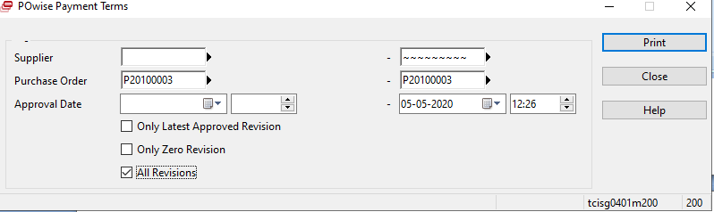

Results are:

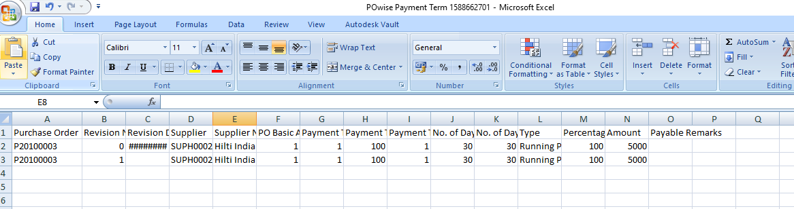

All revision are generated.

As per input we tested as per Supplier also

Tested Supplier as similar to PO testing process:

1)

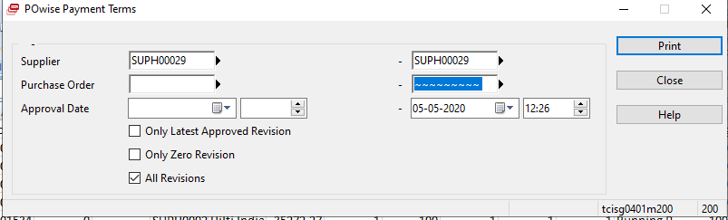

Results are:

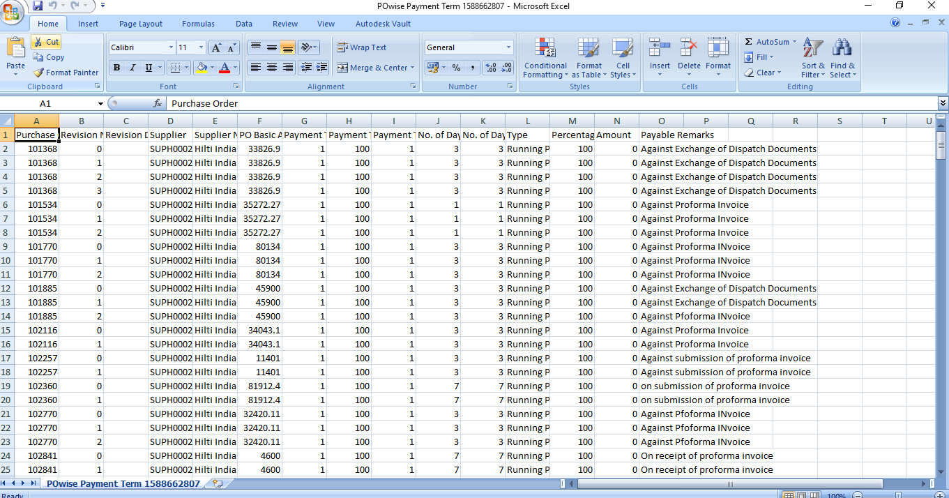

2)

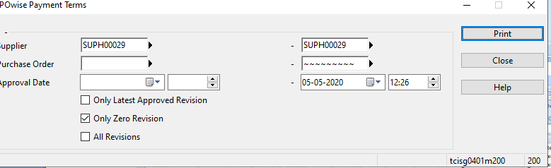

Results are:

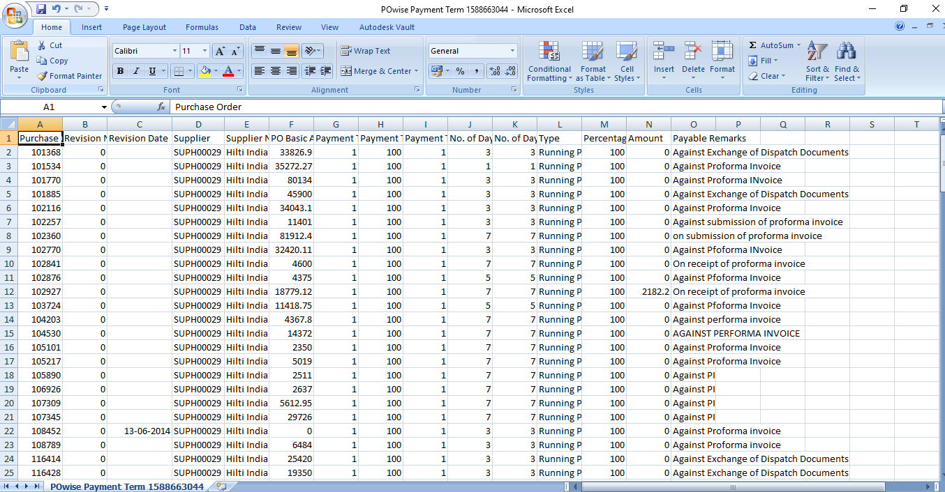

3)

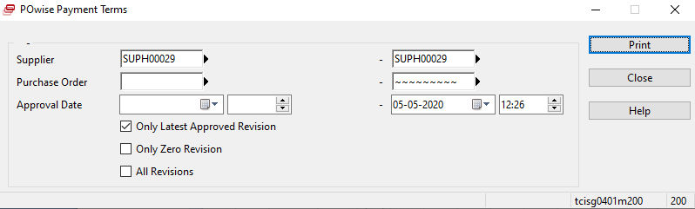

Results are:

